BUILDING ON OUR

Faith

Pleasant Union Christian Church of North Raleigh
PLEDGE FORM

Pledge Timeline: 2019 thru 2025 (or sooner):

Project Options:
- Multi-Purpose Building & Additional Parking = $1.2M-$1.3M
- Total New Construction & Additional Parking = $1.8M-$2M
- Additional Parking & Upgrades = $250K-$300K

I (we) commit to pledge the following over a 7-year period or in lump sum payment:

Amount Pledged | Annual | Monthly | Weekly
$5,000.00 | $714.29 | $59.52 | $14.88
$7,000.00 | $1,000.00 | $83.33 | $20.83
$10,000.00 | $1,428.57 | $119.05 | $29.76
Other

Total Pledge Amount: ______________________________

“I believe this is a defining moment for our church and
I will not hold back on my obligation.”
I prayerfully commit to step out on faith and pledge to give above my “Tithing” over the period of time it takes me to meet the above obligation.

Name: ____________________________________________
Address: ___________________________________________
City, State, Zip Code: _______________________________
Email: _____________________________________________

Signature: __________________________________________

Date: ______________________________________________

Pastor Signature:____________________________________

Examples Are Not Actual Drawings or Specifications

Multi-Purpose Building & Parking Option (1)
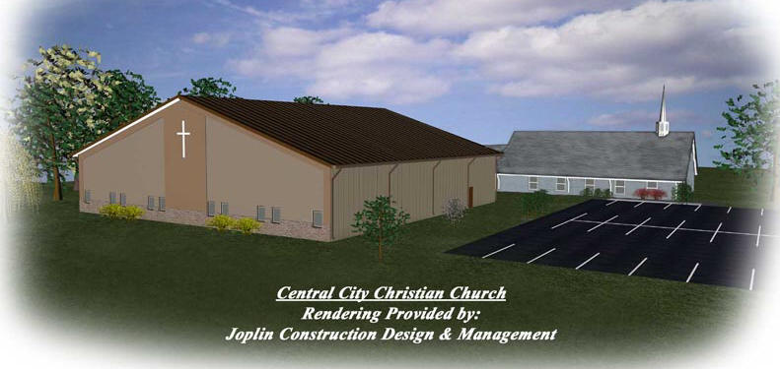

Reconstruction & Parking Option (2)
Additional Parking Option (3)

